Experiment Snapshots on andersbrownworth.com:

After entering data into block 1, and before mining it:

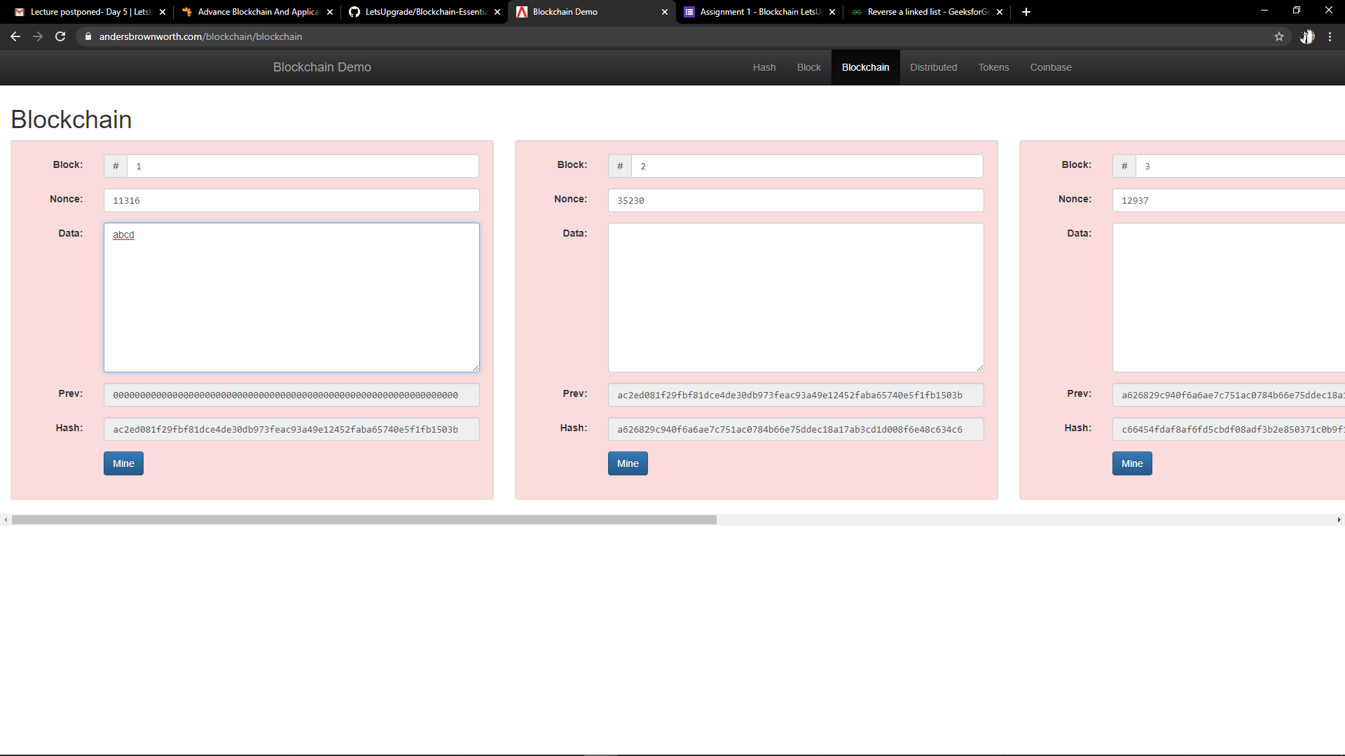

After mining data in block 1:

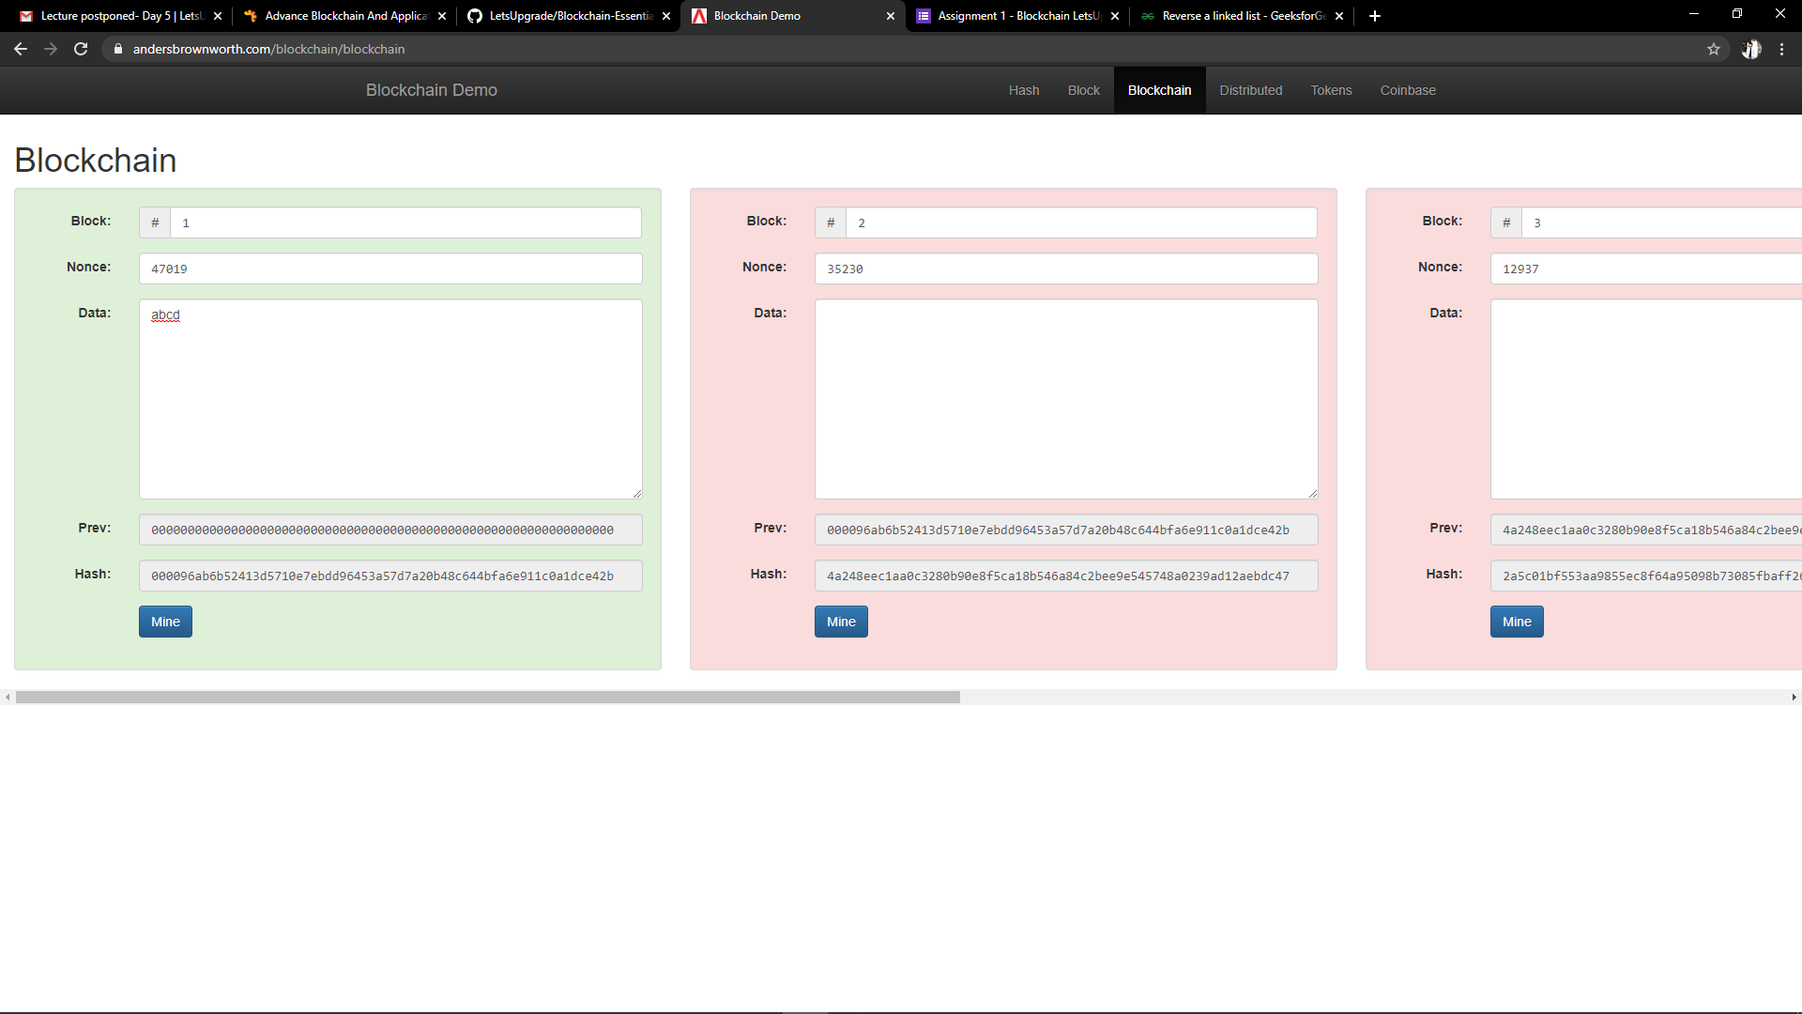

Similarly after doing the same with other following blocks, it looks something like this:

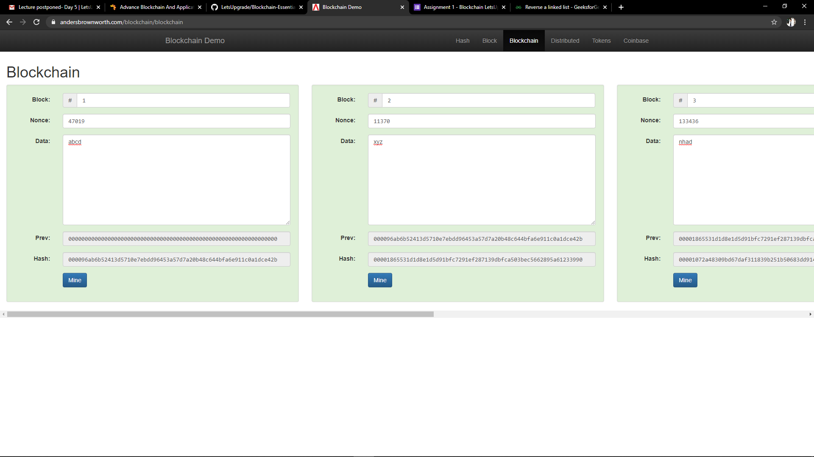

Now let me make a change in data of Block number 2, it is represented as below:

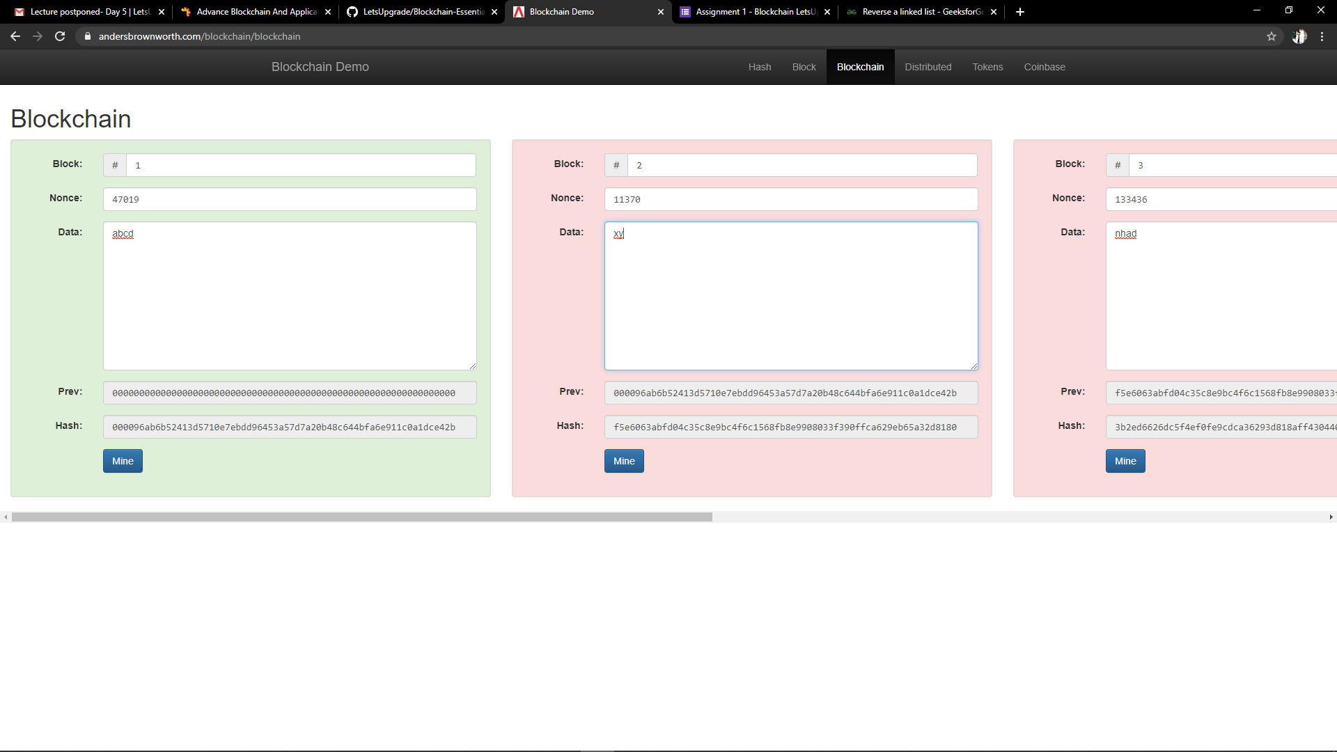

Hence, we can see that the changes made in block are reflected from that point itself, and it is easier than the traditional systems where either, we cannot identify the changes made in them, or it is very difficult to identify them.